

**CS 491-SENIOR DESIGN PROJECT**

**PROJECT SPECIFICATIONS REPORT**

**PROJECT NAME: POLLSTAR**

**SUPERVISOR: H.Altay Güvenir**

**MEMBERS: Nergiz Ünal, Yağız Gani, Gökalp Köksal, Berk Türk, Mustafa Mert Aşkaroğlu**

Table of Contents

1. Introduction 3

1.1. Description 4

1.2. Constraints 6

1.2.1. Economical Constraints 6

1.2.2. Implementation Constraints 6

1.2.3. Recognition Constraints 6

1.2.4. Ethical Constraints 6

1.2.5. Time Constraints 6

1.2.6. Language Constraints 6

1.2.7. Customer Demand Constraints 7

1.3. Professional and Ethical Issues 7

2. Requirements 8

2.1. Functional Requirements 8

2.1.1. User Profile 8

2.1.2. Survey Screen 8

2.1.3. Analysis Screen 8

2.1.4. Marketplace Screen 9

2.2. Non-functional Requirements 9

2.2.1. Usability 9

2.2.2. Security 9

2.2.3. Scalability 9

2.2.4. Reliability 9

2.2.5. Portability 9

2.2.6. Extensibility 9

2.2.7. Extras 9

3. References 10

# Introduction

Collecting data have remarkable significance for foundations. Since, analysis of collected data always play an integral role to determine a road map about future plans. Accordingly, foundations use various techniques to collect data such as social media, cookies, interviews and surveys. These all techniques contain several difficulties and easiness in it.

In this project we will focus on collecting data with surveys. Lots of foundations need reliable and ethical surveys to gather data. In addition to that this need created a business sector to making profit by satisfying this necessity of foundations. There are companies which are making surveys and data analysis. These companies are necessary because they are reliable bridge between people and foundations. People trust this companies about their personal information and survey answers will be secured.

However, as far as we concerned trusting survey companies is not the best way to solve issue of trust. Furthermore, it is possible to see remarkable amount of privacy violation at present time. For instance, Facebook privacy scandal is current and appropriate example to prove that even one of the biggest company is not trustable enough [1]. Therefore, trusting to intermediary companies is not the right way to handle that problem.

*PollStar* application aims to deactivate intermediary companies by solving the issue of trust. Our application will provide people with confidential platform to state their ideas, personal information and comments. We are going to use various popular techniques (blockchain, crypto-encoding) to guarantee privacy of users. Moreover, our application will consider benefits of foundations which want to make surveys by using our application.

## Description

Today, most of the companies give extreme attention to public consumption statistics. Data collecting and processing is a key stage for surveys that are made for the market strategies. Think of a scenario that “X” company wants to know the data analysis about the clothing consumption in Istanbul province between 2017 and 2018. Regarding that intel, “X” brand may want to open additional stores in various locations of Istanbul. Or, they may want to cut their investment down in Istanbul province. So the data for these strategies and plans of “X” company will be provided by *PollStar* application.

*Pollstar* is a mobile application that requires internet connection to collect the data that the user enters. Process these data using efficient data structures and algorithms in the background. The program’s efficiency is provided by blockchain structure. All the data will be stored in blocks that are located in the chain. These data will be encrypted by using various efficient methods. The system will use 256-bit encryption. By using zero-knowledge-proof, data privacy of the users will be acquired.[2]

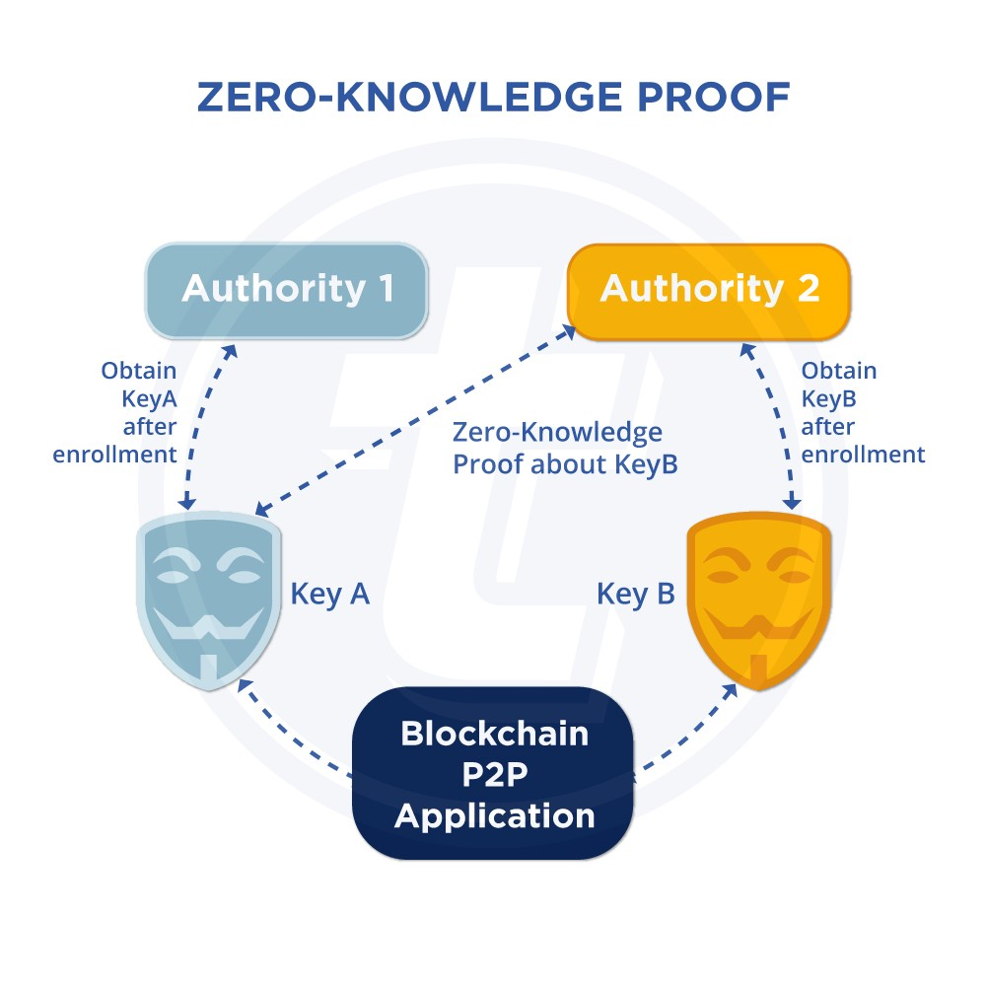

Figure 1: Zero knowledge proof [2]

Another question that comes to mind is, how to prevent one person to vote more than once. To avoid this issue, the system will set some kind of temporary ID or key to each user in the blockchain and once the voting process ends and data collected, the user won’t be able to vote again. Otherwise the chain will be violated and this violation will definately be seen by others. So this application provides a trust platform between users.

The application eliminates survey companies in this process. Foundations will not have to spend their money on these companies. So the application provides a reliable data bridge between companies and their target audience.

*PollStar* application will use trend technologies like Blockchain and maybe machine learning algorithms in data analysis stage.

## Constraints

### Economical Constraints

Our main motivation is deactivating intermediary companies, thus cost of our program should be not much to minimize our service charge.

### Implementation Constraints

Privacy by design construction style will be used to make our system confidential in terms of privacy.

BlockChain structure will be used to increase safety of our program.

Zero Knowledge Proof algorithms will be used to prove quality of our data.

We will use multiple programming languages together in implementation process.

### Recognition Constraints

Effectiveness of our application is directly proportionate to amount of people who will use it, thus we have to increase recognition of our application.

### Ethical Constraints

Ethics of National Society of Professional Engineers will be followed [3].

Personal information, ideas and answers of users will be secured sensitively.

### Time Constraints

Implementation and reports of our application should be finished before the deadline.

### Language Constraints

Our application will be published in Turkish, yet other language versions can be published according to demands.

### Customer Demand Constraints

Various types of surveys and data analysis should be enabled to satisfy customer demands.

Quality of our data which will be processed should be proved to excite foundations’ interest.

## Professional and Ethical Issues

Our project contains various professional and ethical aspects. For instance, collecting data includes both professional and ethical difficulties in it. Collecting data process is markedly sensitive. We have to give significance about not violating the privacy of people who are our data source. Our system has to be reliable from user point of view to collect accurate and reliable data. Moreover, implementing this kind of system requires remarkable amount of professional works.

We have to implement our codes by following privacy by design coding construction style. Furthermore, we have to learn and practice about new concepts which are useful to guarantee that privacy of users. In addition to that, practicing and learning about new concepts is always tough process for computer scientists. Since, amount of sources and project examples are not much according to other concepts.

On the other hand, we have to consider about benefits of the foundations we will work with. Since, they are the main financier of the project. However, we must obey the rule of ethics while we are doing that. It will be also tough for us during the implementation process.

# Requirements

## Functional Requirements

### User Profile

Every user must have a unique ID, email address and password. The user can access the system through validation of these variables.

A login screen will be shown up when the application opens.

Every user must be able to login by using email address and password.

Email or SMS notification service will be provided to the user.

Every user must be notified by the system for different situations. For example: login failed, login timeout, voted successfully, etc.

Every user must be able to check for their online coins which are earned by joining the surveys.

### Survey Screen

Every survey has a category, survey ID, related foundations, etc.

A survey list will be provided to the users and users will be able to vote any survey they want by selecting the related one from the list.

The deadline of survey will be provided on the survey screen.

Number of people who voted for this survey will be shown on the screen.

### Analysis Screen

Results of surveys must be visualized by admins.

Analysis types which will be actualized must be selected by admins.

Data analysis process must be started by admins.

Data analysis of results must be visualized by admins.

Various graph types must be visualized by admins.

### Marketplace Screen

Products and their prices must be visualized by users.

Users must be able to make order by using their online coins.

## Non-functional Requirements

### Usability

The user interface should be simple enough and user friendly.

### Security

The system should be secure enough not to violate personal data of the users. The system should store the personal data of users after hashing it. So the personal information must be encrypted.

### Scalability

System should give response and handle many users synchronously.

### Reliability

One user should not contribute a survey more than once to collect a reliable and proper survey result.

### Portability

The system should be running on mobile & desktop web platforms.

### Extensibility

The system should allow developers to update their code and services.

### Extras

Network & Internet connection is required.

Database required to store the survey result information and user profile data.

# References

**[1]** “ Security | Facebook Privacy Scandal: A Cheat Sheet” ,techrepublic.com, 2018. [Online].

**[2]** TokenPay, “TokenPay Transactions are Zero-Knowledge Proof – TokenPay – Medium,” *Medium*, 02-Nov-2017. [Online]. Available: https://medium.com/@TokenPay/tokenpay-transactions-are-zero-knowledge-proof-5798176cde59. [Accessed: 13-Oct-2018].

Available: <https://www.techrepublic.com/article/facebook-data-privacy-scandal-a-cheat-sheet/>

**[3]** "Code of Ethics | National Society of Professional Engineers", Nspe.org, 2017. [Online]. Available: https://www.nspe.org/resources/ethics/code-ethics. [Accessed: 07- Oct- 2017].